ANNUAL PERMIT/SEASON TICKET APPLICATION FORM (April 2022 to March 2023)
TITLE:
FORENAME:
SURNAME:
POSTCODE:
ADDRESS:

CONTACT NO:
E-MAIL:
VEHICLE REGISTRATION 2:
VEHICLE REGISTRATION 1:

EMERGENCY CONTACT NO:
EMERGENCY CONTACT NAME:

IF STORAGE IS PURCHASED A MEMBERSHIP MUST ALSO BE PURCHASED. ANY COMBINATION OF SEASON TICKETS INCLUDE A MAXIMUM OF 2 ANNUAL PARKING PERMITS (ANNUAL PARKING PERMITS ARE NOT INCLUDED WITH A JUNIOR SEASON TICKET). RENEWAL FEES ARE DUE BY 1ST JULY, SEE TERMS AND CONDITIONS FOR DETAILS.
 | Quantity | Fees
FAMILY SEASON TICKET (2 ADULTS & UP TO 3 JUNIORS) |  | £205
ADULT SEASON TICKET (18-60) |  | £147
SENIOR SEASON TICKET (60+) |  | £116
JUNIOR SEASON TICKET (UNDER 18’s) |  | £55
ANNUAL STORAGE (1st April-31st March) |  | £147
MONTHLY STORAGE |  | £75
OVERNIGHT STORAGE |  | £15

Sub-Total
Discounts
Total
Payment methods accepted: cash, credit/debit card and cheques (Cheques are payable to Anglian Water Ltd)
[*telephone payments via credit/debit card can only be processed upon the receipt of a fully completed and signed application.]
Declaration: [please read and sign below]
I have read the ‘ALTON WATERSPORTS CENTRE: TERMS AND CONDITIONS FOR PERMIT HOLDERS OF ANY TYPE’ and agree to abide by them.
I have read the ‘ALTON WATERSPORTS CENTRE/ANGLIAN WATER SERVICES - RULES OF SAILING 2022-2023’ and agree to abide by them.
I agree to abide by the Anglian Water Ltd. Water Parks Byelaws 2014.
I hold valid and adequate third-party liability boat insurance cover to a minimum value of £5,000,000.
By proceeding with making payment for your season ticket/ permit you are agreeing to abide by all Terms and Conditions/ Rules of Sailing/ Anglian Water Ltd. Water Parks Byelaws 2014 and insurance requirements.
Signed: Date:
Page 1 of 3

DETAILS OF CRAFT KEPT AT ALTON WATERSPORTS CENTRE:
[THIS SECTION MUST BE COMPLETED IN ALL CASES]
CRAFT CLASS  (Laser, RS 200 etc) | NAME OF CRAFT/HULL (SAIL) NUMBER | HULL COLOUR | DECK COLOUR
PERMITS WILL ONLY BE PROCESSED WHEN ALTON WATERSPORTS CENTRE HAS RECEIVED A SIGNED APPLICATION FORM AND A SIGNED TERMS AND CONDITIONS, WITH ALL FIELDS COMPLETED.
ANY BOATS STORED AT ALTON WATERSPORTS CENTRE WITHOUT VALID PERMIT WILL BE LIABLE TO UNDERGO PROCEEDINGS WHICH COULD RESULT IN ALTON WATERSPORTS CENTRE TAKING POSSESSION OF THE CRAFT.
PLEASE NOTE:
THE BOAT PARKS ARE REGULARLY MONITORED TO GUARANTEE OUR RECORDS ARE KEPT UP TO DATE.
PLEASE ENSURE YOUR BOAT AND PERMIT DETAILS ARE ALWAYS KEPT UP TO DATE.
DO NOT HESITATE TO CONTACT THE CENTRE IN THE EVENT OF A QUERY REGARDING YOUR BOAT STORAGE.
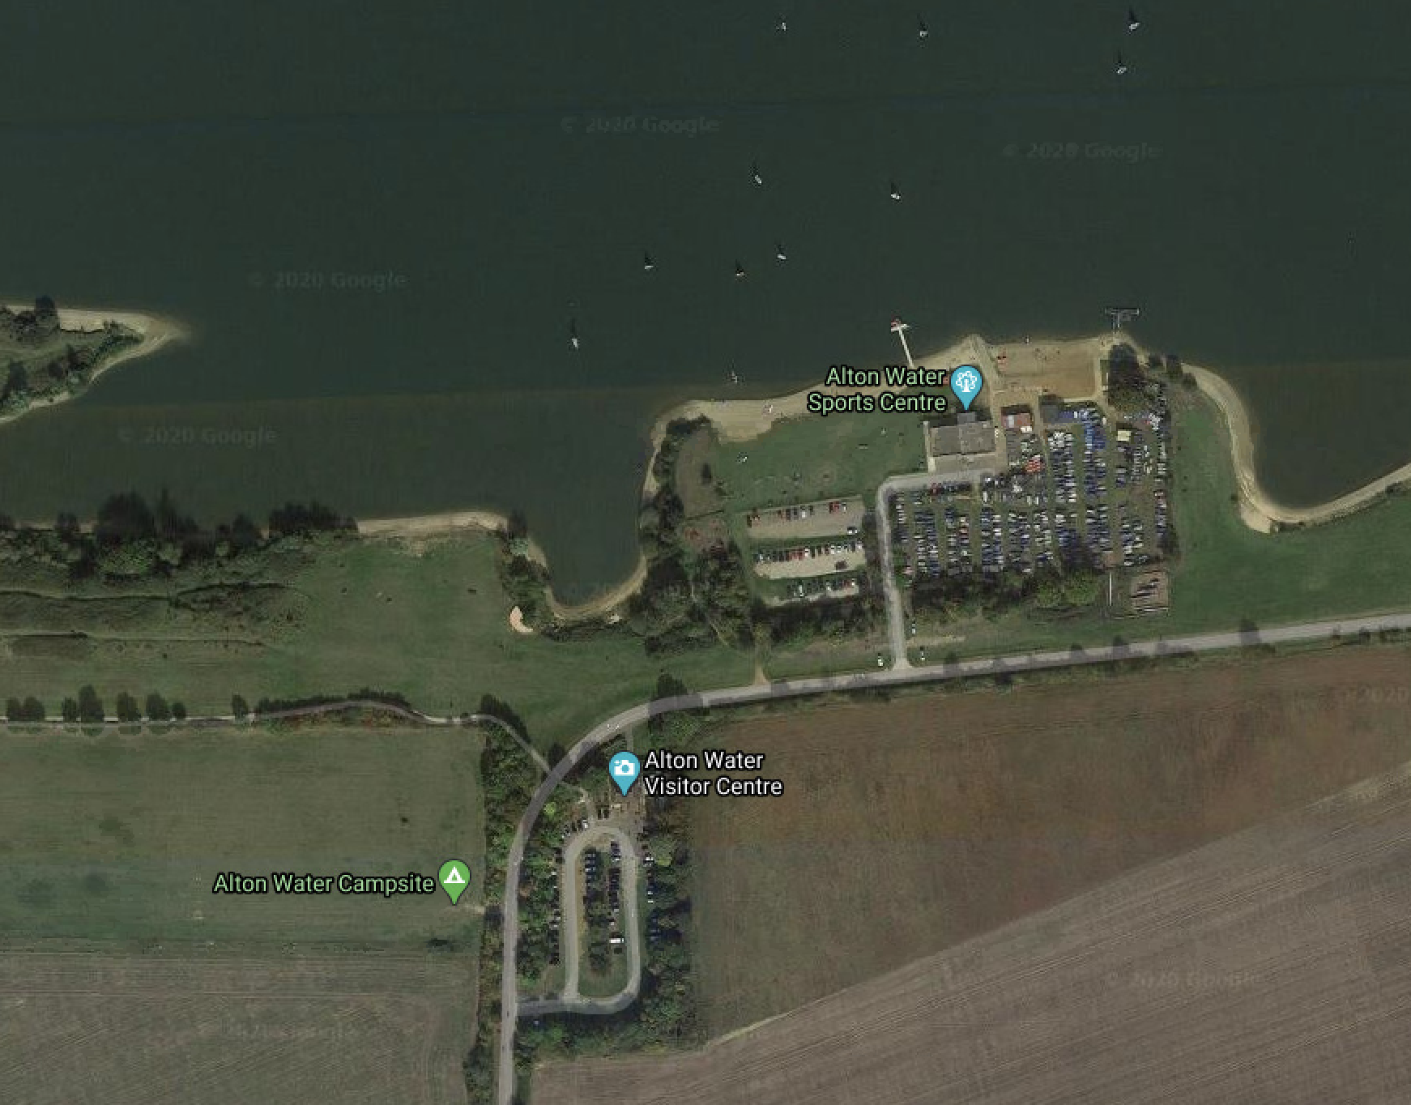

Alton Water sports Centre

Car Parking

Dinghy Park

How information about you will be used
We will only use your personal data to provide you with the product or service you have requested. For more information on how we may use and share your information, please read our Privacy Policy (www.anglianwater.co.uk/privacy).

Stay In Touch
The Recreation Team would like to send you information about events and services at our Waterparks and products we sell by email or text. If you are happy to be contacted in this way, please tick the relevant boxes:
Email: Text:
If you are happy to receive information about products, services, special offers or promotions by any other member of the Anglian Water Group, please let us know by ticking the relevant boxes:
Email: Text:
To unsubscribe, just email with the word UNSUBSCRIBE in the subject line and your name to recreationteam@anglianwater.co.uk and we will stop sending you information on our events and services.

Page 2 of 3

Alton Water sports Centre OFFICE USE ONLY
PERMIT NUMBER 1 |  | DINGHY PARK SPACE
PERMIT NUMBER 2 |  | DINGHY PARK SPACE
PERMIT NUMBER 3 |  | DINGHY PARK SPACE
 |  | PROCESSING STAFF (NAME)

Page 3 of 3

